**Homework-07 田晓妍**

**The questions:**

Please use QGIS to transfer the utm coordinates of sampling points of the Doubs dataset into geographic ones and record all steps in word file.

1. **Sampling points without referenced**

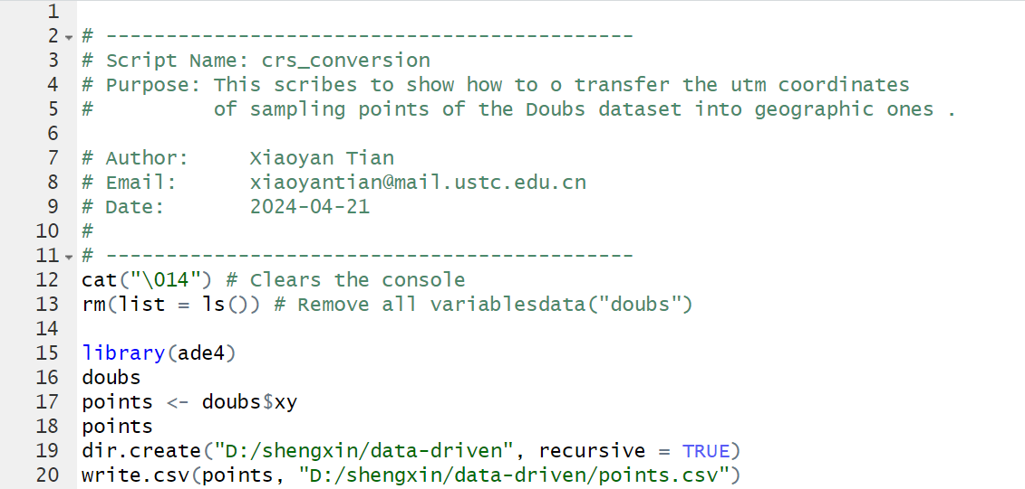



1. **Using QGIS to convert csv to an image**

**2.1 Importing the data and adding layer**

Choosing Layer--Add Layer--Add Delimited Text Layer, please note to check “Geometry CRS” is “EPSG : 4326 – WGS 84”.

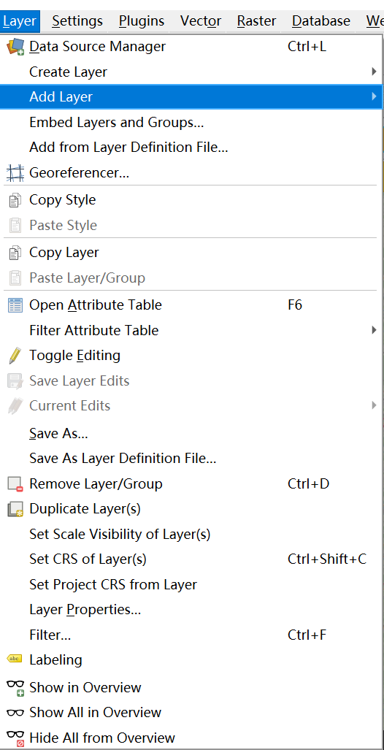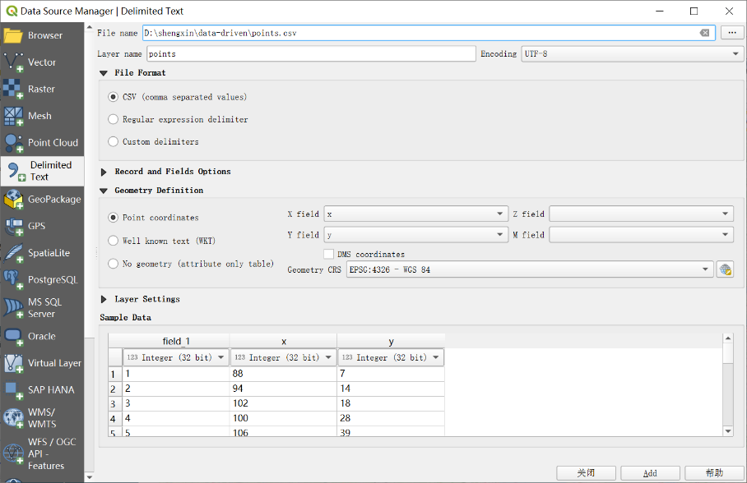

**the result can be illustrated on the layer:**

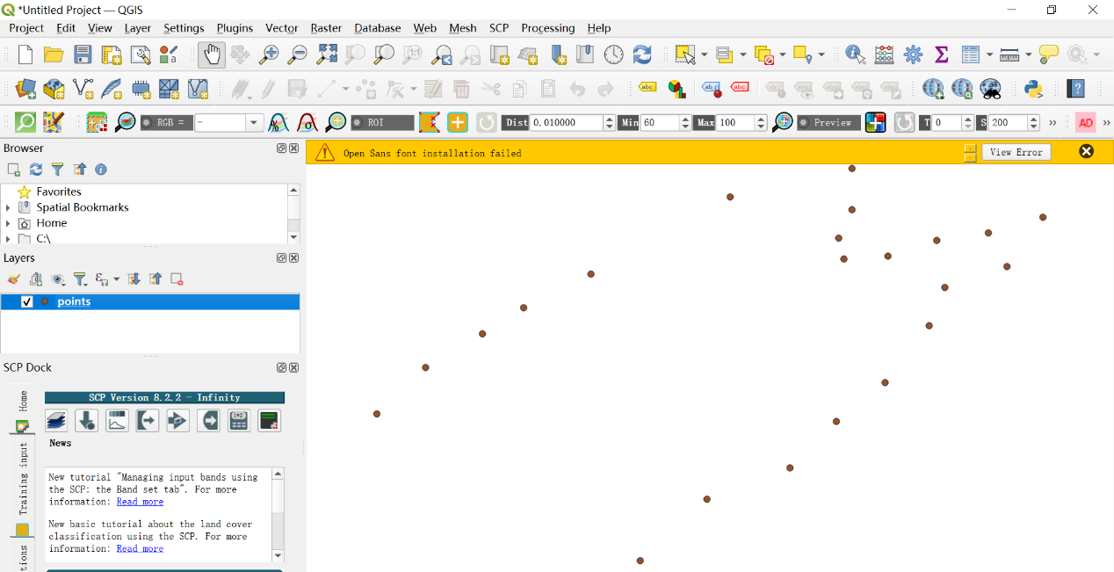

* 1. **Checking the information of layer properties of points**

Right click “points”, and click “properties” to confirm the coordinate reference system is WGS84.

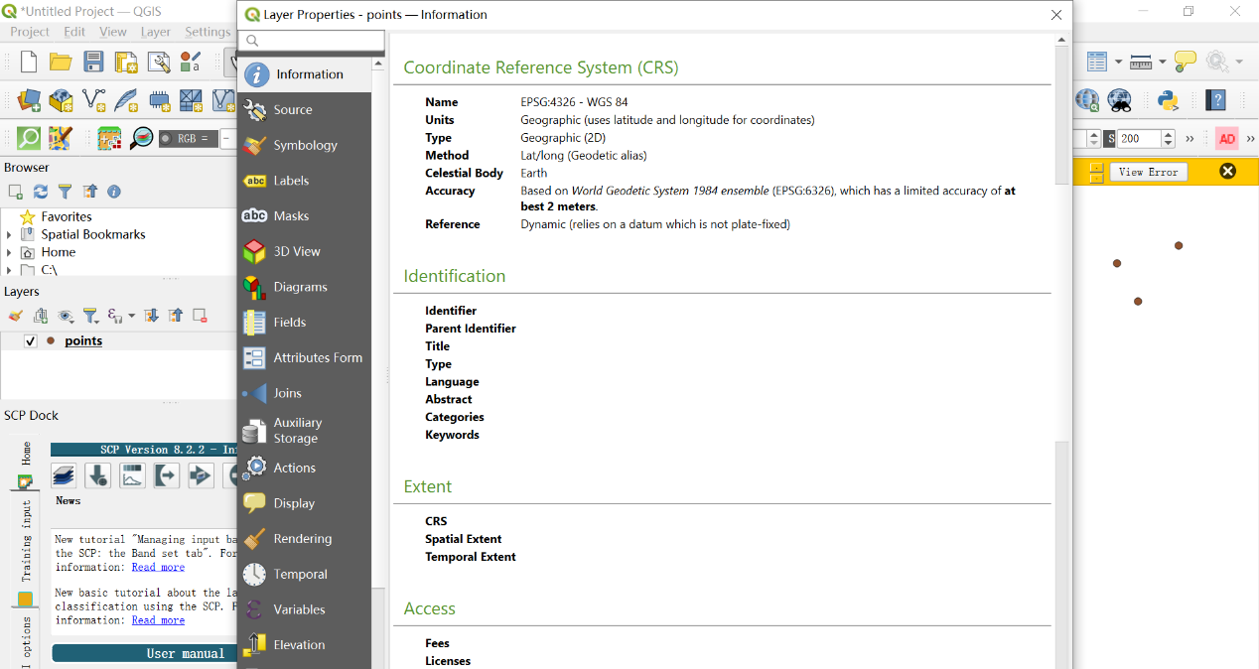

**2.3 Converting and saving map as an image**

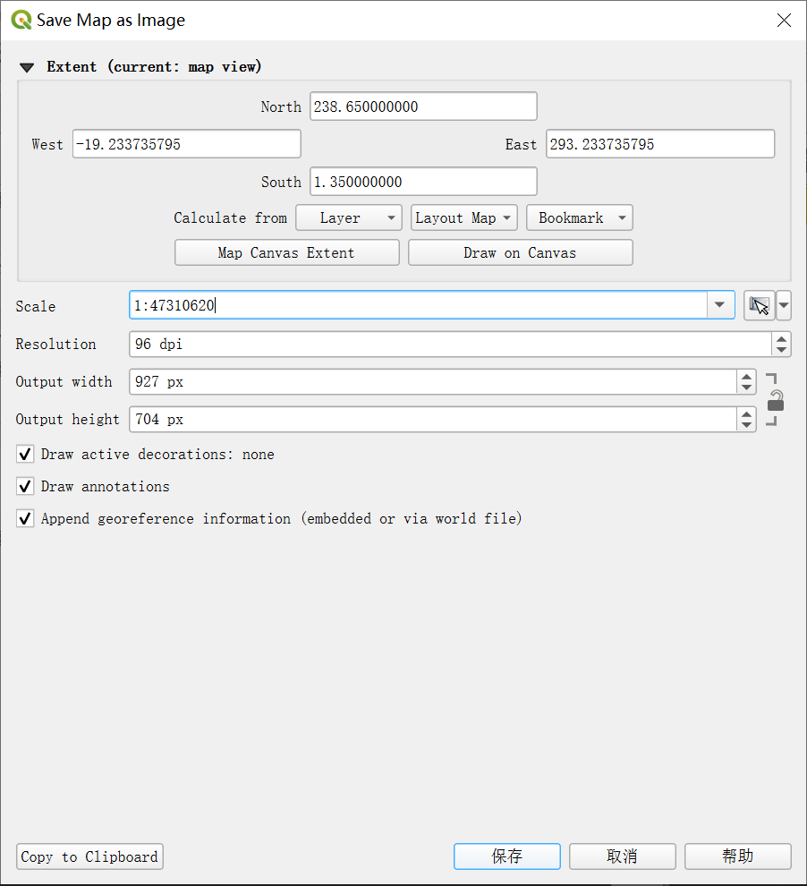

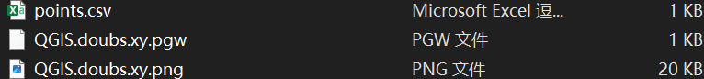

1. **Using plugin to georefer the image**

**3.1 Install the plugin, “Freehand raster georeferencer”，click  and import“QGIS.doubs.xy.png”**

**The png file was successfully added to the layer:**

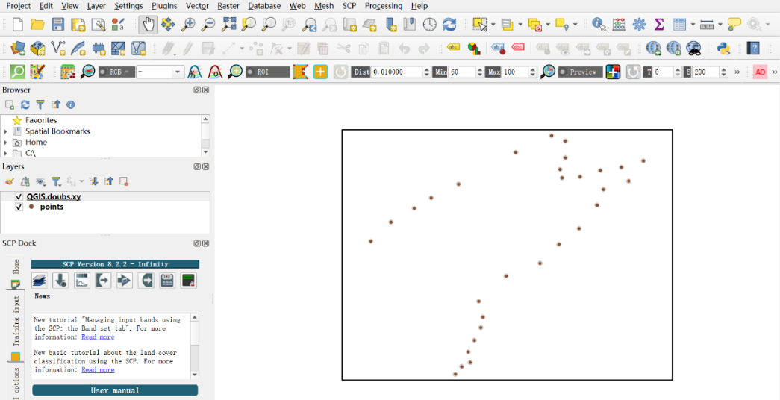

**3.2 Install the plugin, “QuickMapServices”，chosse Web – QuickMapService – OS -- OSM Standard , the map was added :**

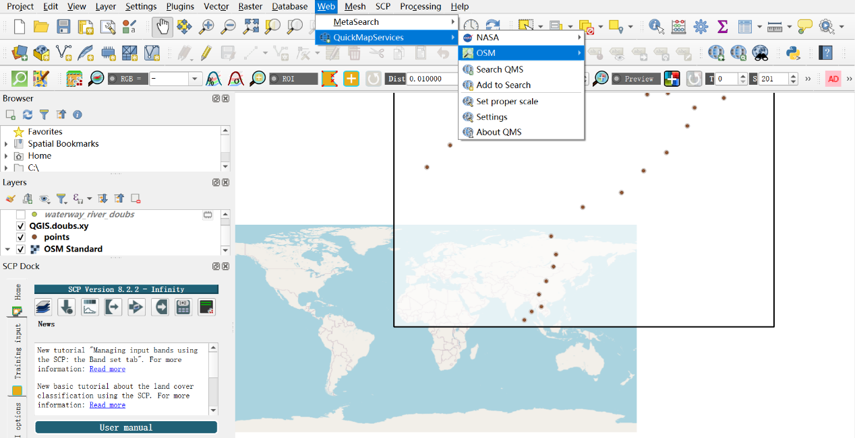

**3.3 Install the plugin, “QuickOSM” , for querying and loading the true river of “Doubs”**

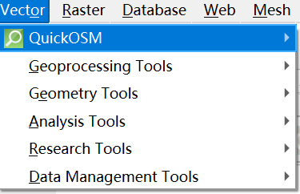

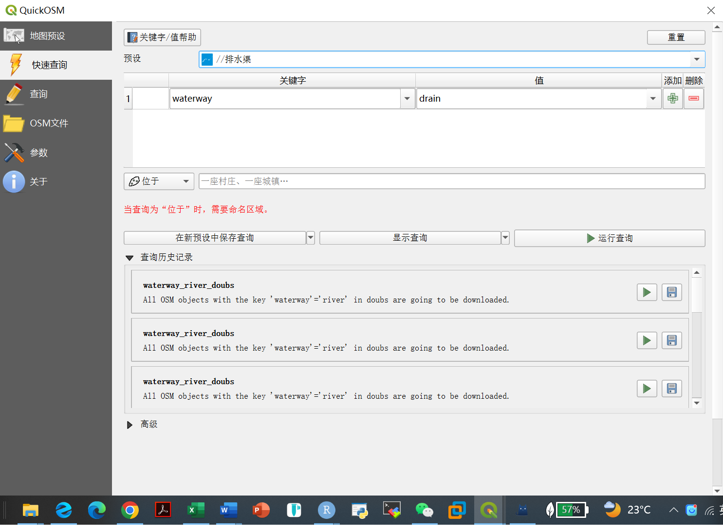

**The layer of “waterway_river_doubs” as seen below and change to the noticeable symbology:**

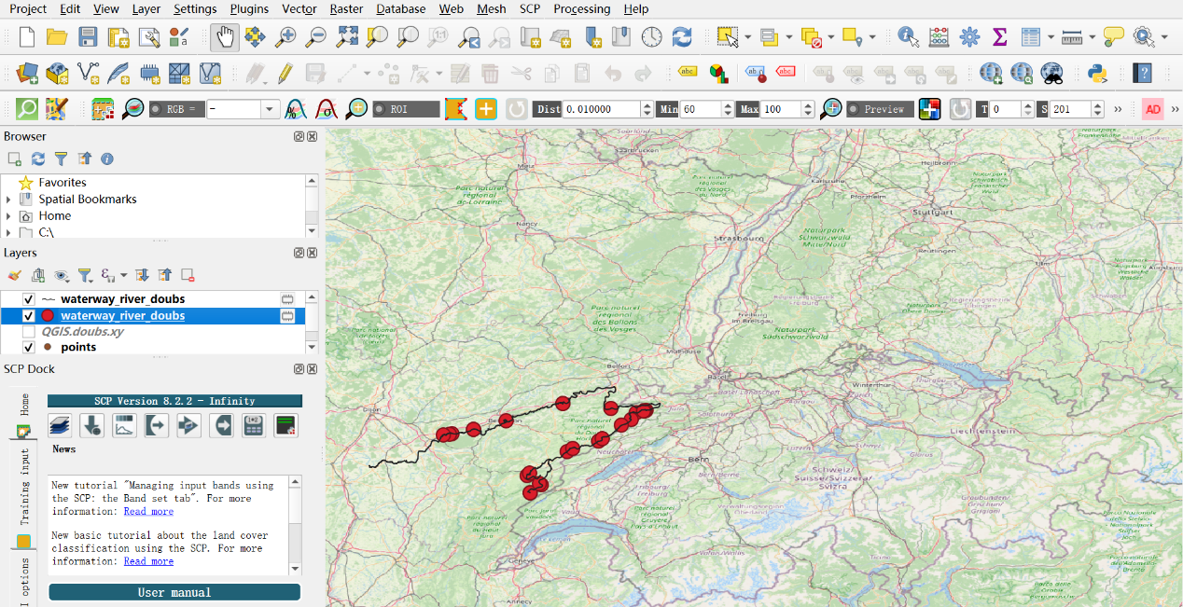

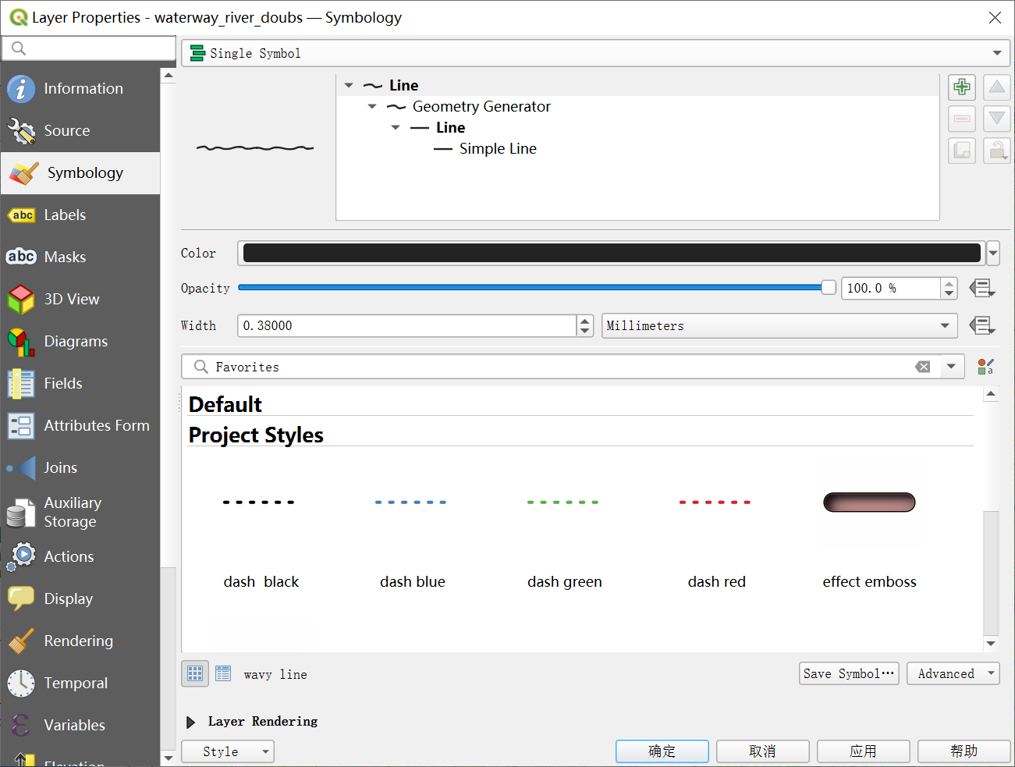

**3.4 Adjust the raster picture, with Freehand raster georeferencer 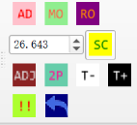 ,MO(Move raster), RO(Rotate raster) and SC(Scale raster) aiming to match the points exported as the picture on the step 3,1 and the waterway line on the map.**

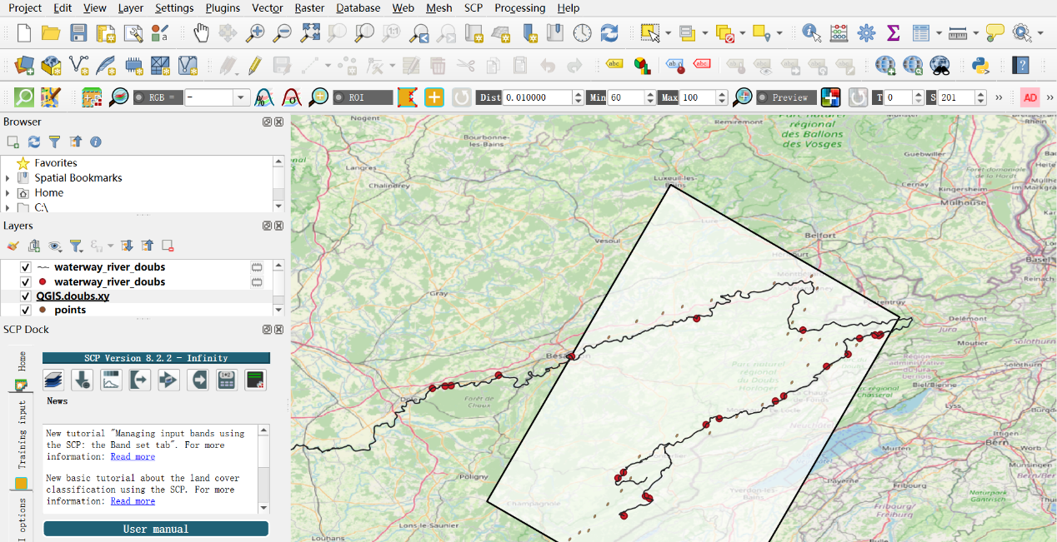

**3.5 Choose the clicked layers and save the image as “doubs.georefer.png” by “Project--Import/Expor--Export Map to Image”**

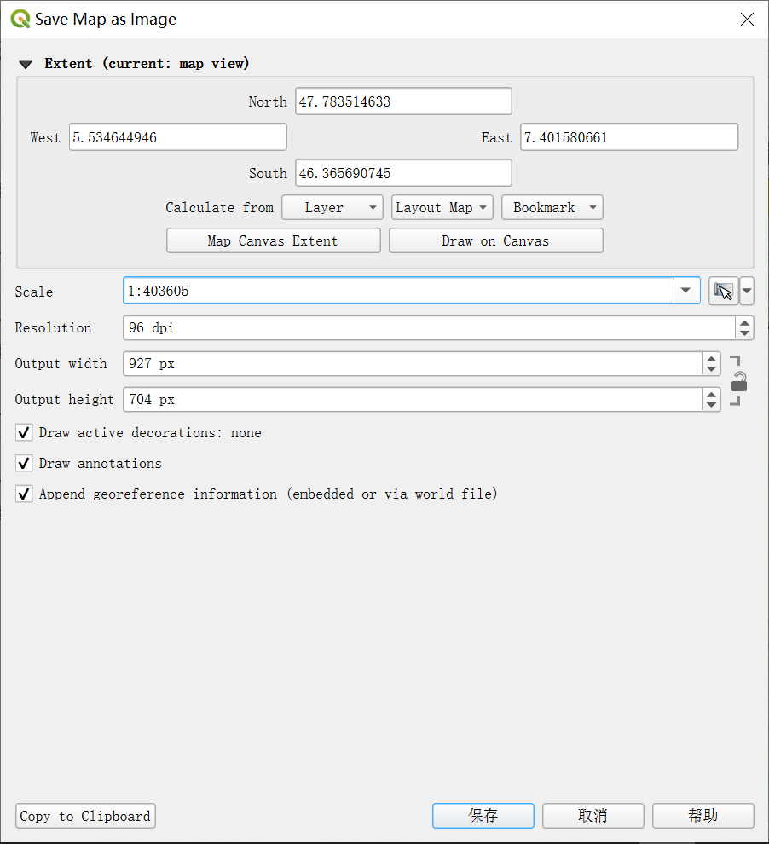



1. **Transfering geographic coordinates**

**4.1 Import the “doubs.georefer.png” by choosing “Layer--Georeferencer File--****” to open the raster.**

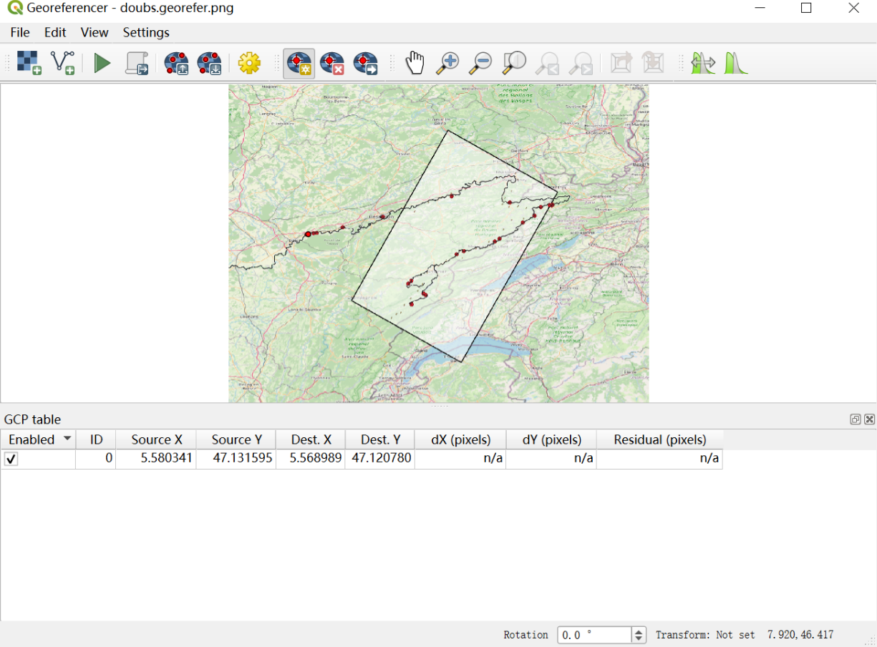

**4.2 Proceed by add points that appear on the map of Georeferencer using** **. Subsequently, selecting the first point, click "From Map Canvas" and then select the corresponding point on the raster image of the map.** 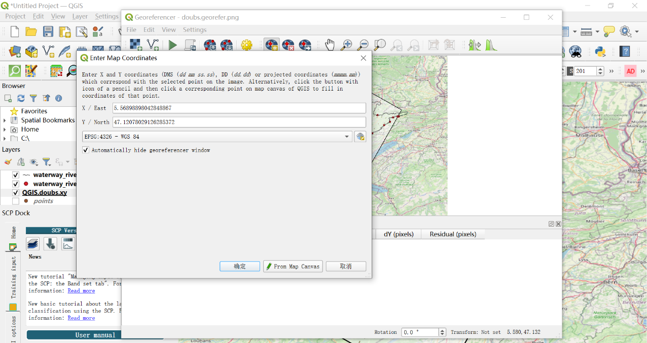

* 1. **Repeat the procedure for the 30 points one by one**

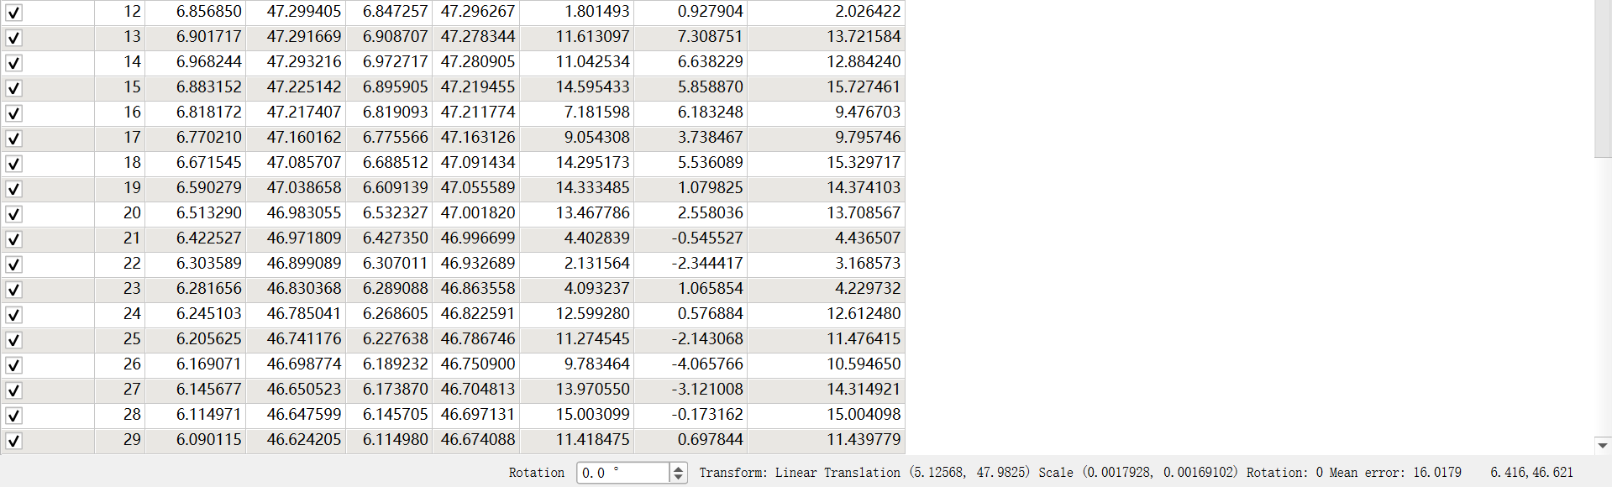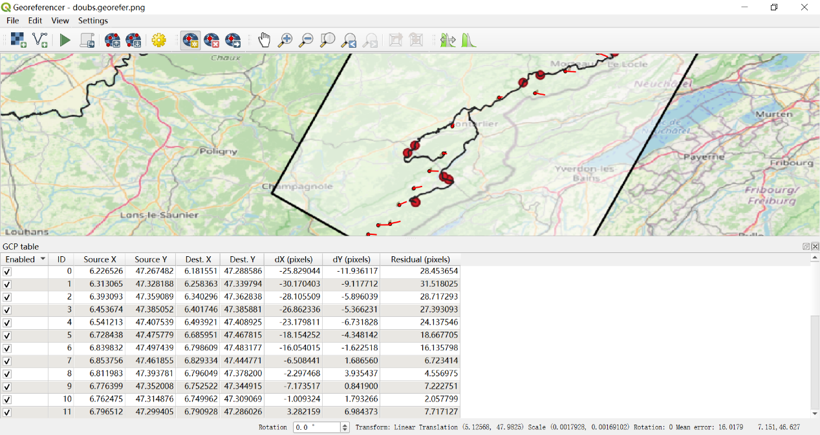**4.4 Start Georeferencing using**  **and save GCP Points as “doubs.georefer.points” after which change file extension to the “.csv”**

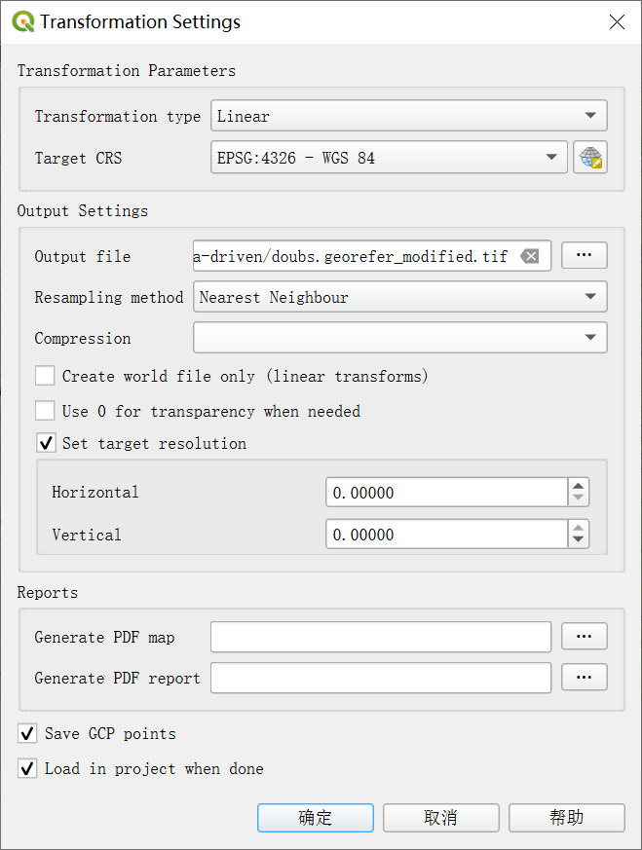





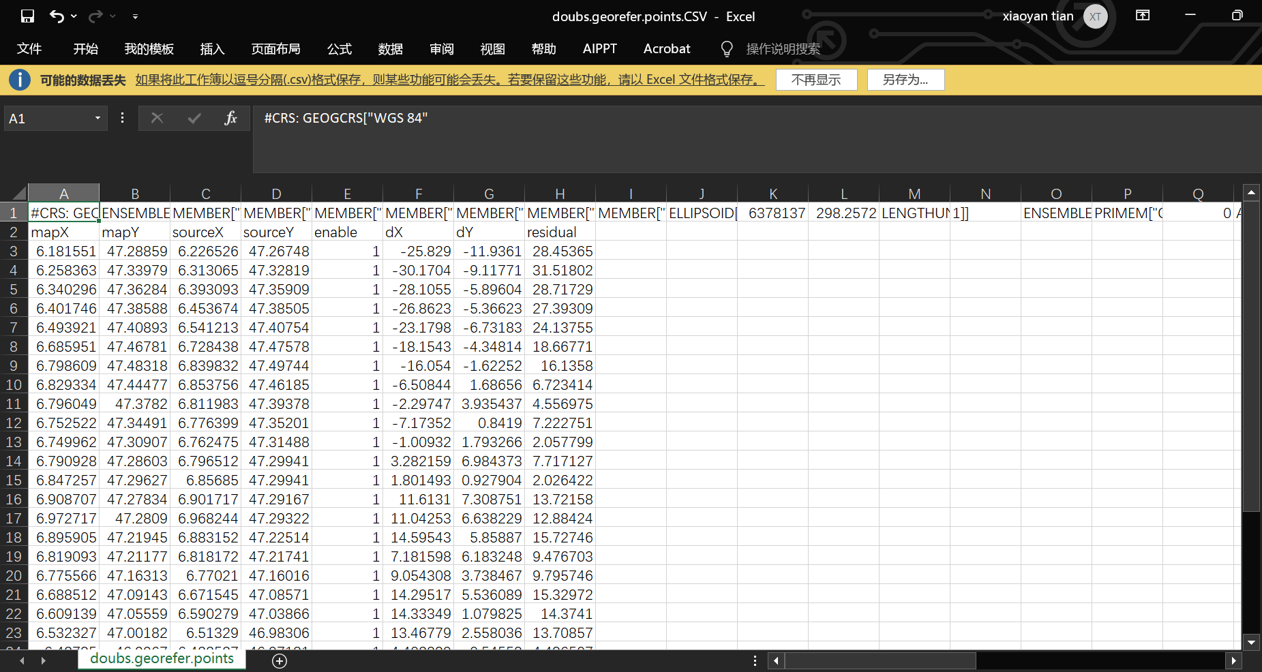

1. **Extracting geographic coordinates in RStudio**



Reference: https://docs.qgis.org/3.34/en/docs/user_manual/working_with_raster/georeferencer.html#available-transformation-algorithms